

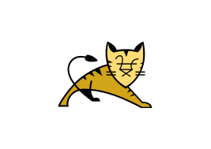

Explore

**Apache Tomcat** is an open-source implementation of the Jakarta EE specifications for web applications. [It serves as a web server and servlet container, allowing the deployment and serving of Java web applications1](https://tomcat.apache.org/)[2](https://en.wikipedia.org/wiki/Apache_Tomcat).

Here are **five free reference links** where you can learn more about Apache Tomcat:

1. [**Apache Tomcat Official Documentation**](https://tomcat.apache.org/): The official website provides comprehensive information about Tomcat, including installation, configuration, and usage.
2. [**Baeldung’s Introduction to Apache Tomcat**](https://www.baeldung.com/tomcat): This tutorial covers installing Tomcat, configuring the Tomcat Manager, and creating SSL certificates for serving HTTPS content.
3. [**Udemy Course: Apache Tomcat for Beginners and Advanced**](https://www.udemy.com/course/apache-tomcat-for-beginners-and-advanced/): A course that starts with basic concepts and progresses to advanced topics in Tomcat server configuration.
4. [**TutorialKart’s Apache Tomcat Tutorial**](https://www.tutorialkart.com/apache-tomcat/apache-tomcat-tutorial/): Learn about Tomcat components, installation, and security configuration with examples.
5. [**vogella’s Apache Tomcat Tutorial**](https://www.vogella.com/tutorials/ApacheTomcat/article.html): This tutorial focuses on installing and using Apache Tomcat for Java web development.

Feel free to explore these resources to enhance your understanding of Apache Tomcat! 🚀